Ques 1 -create two files - student.txt and employee.txt and add them to staging area  
  
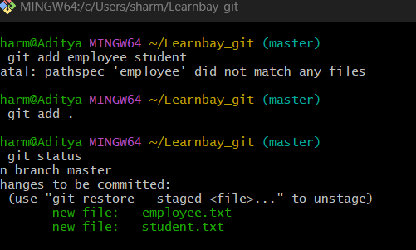  
  
Ques2- add one more file - dept.txt into staging area but at same time restore the employee.txt and modify some changes inside the student.txt  
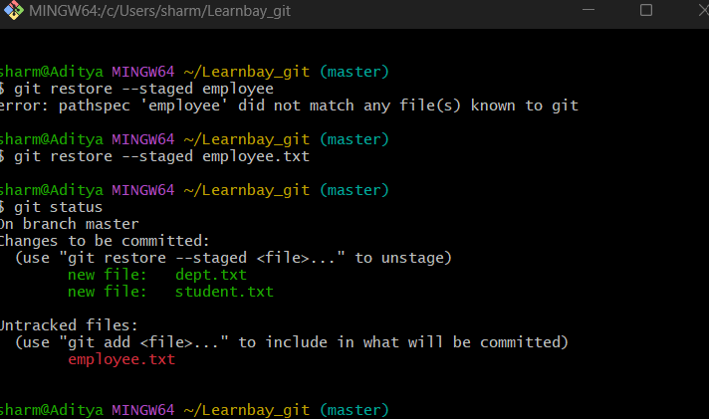  
  
Ques3- push dept.txt, student.txt and employee.txt to the remote repos.  
  
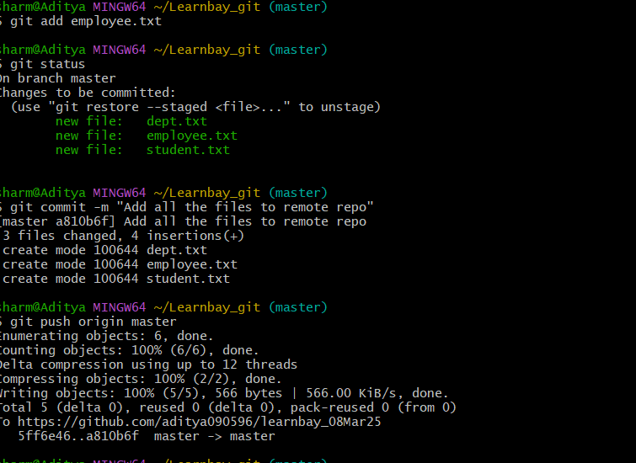  
  
Ques4- create a new file - hello.txt in remote repos directly and bring to the working directory  
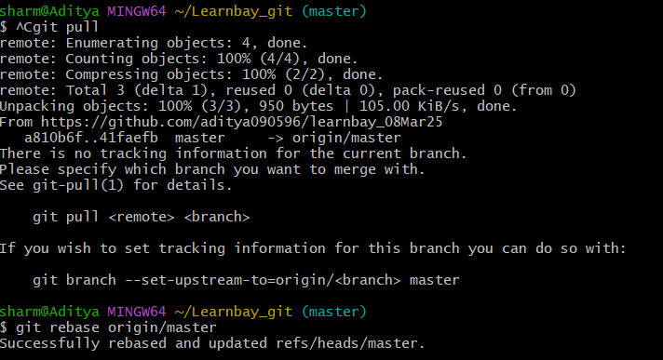

Ques 5- send all files from working directory to remote repos  
  
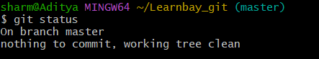  
  
Ques6- remove a file from the remote repos and sync the changes into your working directory  
  
Removed dashboard.txt  
  
  
